China Dragon Boat Festival

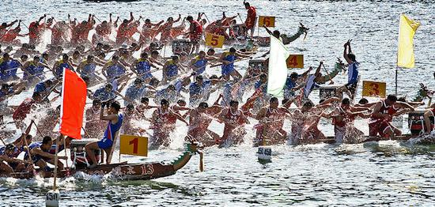

Dragon Boat Festival (Longzhou Jie in Chinese pinyin), also known as Duanwu Festival, is one of the most important traditional festivals in China. There are many folk activities held during the festival like dragon-boat racing, hanging calamus and artemisia, etc.. Dragon Boat Festival is the top four most well-known tradition festivals of the Chinese nation with Spring Festival, Mid-autumn Festival, Tomb-sweeping Day. It originates in China, however, it’s also celebrated in some neighbor countries, like Japan, South Korea, Vietnam.

As one of the oldest festival in China, people like to row dragon boat and eat Zongzi to celebrate in Dragon Boat Festival from ancient times. In 2008, Dragon Boat Festival is designated as a public holiday in China. In 2009, Dragon Boat Festival was selected into world non-material cultural heritage list, and became the first festival selected into world non-material cultural heritage list in China.

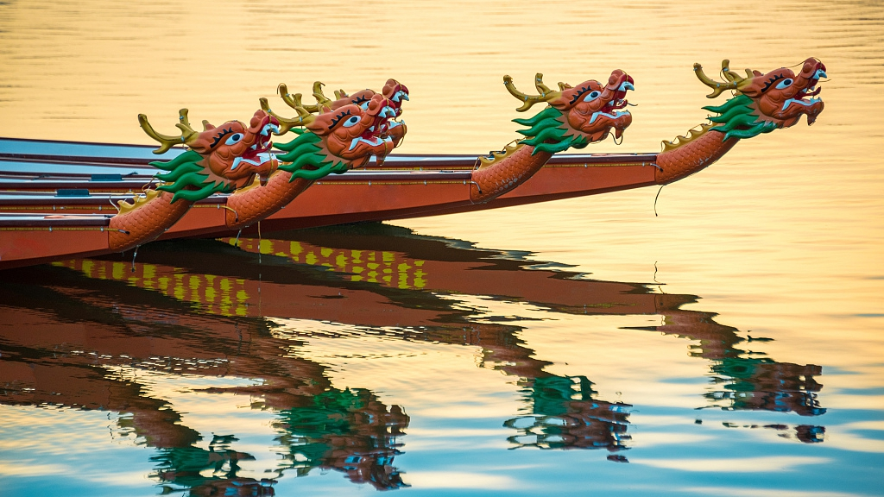

The Dragon Boat Festival is celebrated on the 5th day of the 5th month of the traditional Chinese lunar calendar. The time is also a source of the festival's alternative name, the Double Fifth Festival.

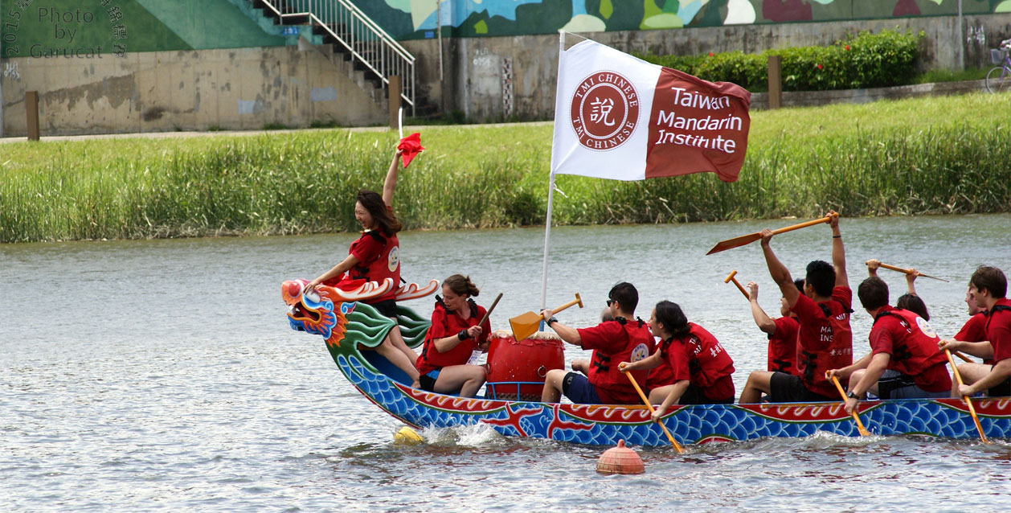

Zongzi is the most representative food of the Dragon Boat Festival. It’s a kind of dumpling made of glutinous rice with leaves outside, meat, bean, nut and some ingredient inside. Different place has different flavor and different ingredient. Generally, Zongzi in south China is salty ones with meat or egg, Zongzi in east China is sweet ones with beans while in north it could be the ones with red dates in it.

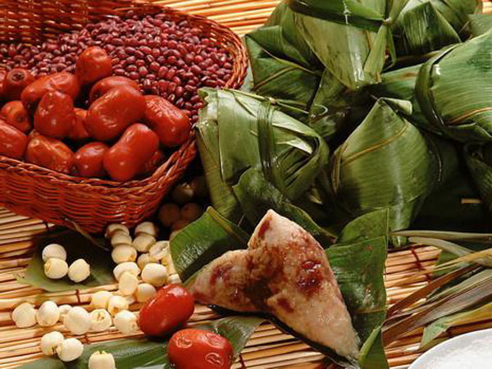

In order to drive the fish away to avoid Qu’s body being bitten, racing boat on the double-fifth day gradually became a classic activity of this festival. Rowers sit on the head of the dragon boat take charge of beating the drum and enhancing other rowers’ morale, other rowers need to make concerted efforts to row.Some places in Guangdong take it more seriously as they do a special ritual to pray for the dragon god’s blessing for this years future before they start racing.

With the weather turning warmer, people are more likely to be infested with disease, so it is somewhat practical to hang calamus and artemisia on the door during the Dragon Boat Festival as their special smell can keep those insects away.In doing this,people also believe that it can somewhat drive bad energy away.

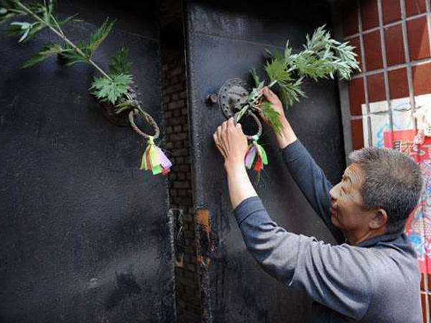

On the dragon boat festival,children are supposed to wear a five-colored chain bracelet on their wrists in a good will to keep them healty and safe,and the chain bracelet should be throw away on the first rain or shower after the festival meaning flush away your disease.  
All of these activities, together with the drinking of realgar wine, were regarded by the ancients as effective in preventing disease or evil, while promoting health and well-being.

